First Assignment
1) With vibe coding implement the playwright/typescript or any other tool which you work say Selenium/Python
Sample prompt for playwright/typescript integration:
Ask mode:
Read my entire workspace and confirm me what are the files will be impacted if I want to add playwright typescript same like implemented for Selenium Java

Existing: Python/Selenium
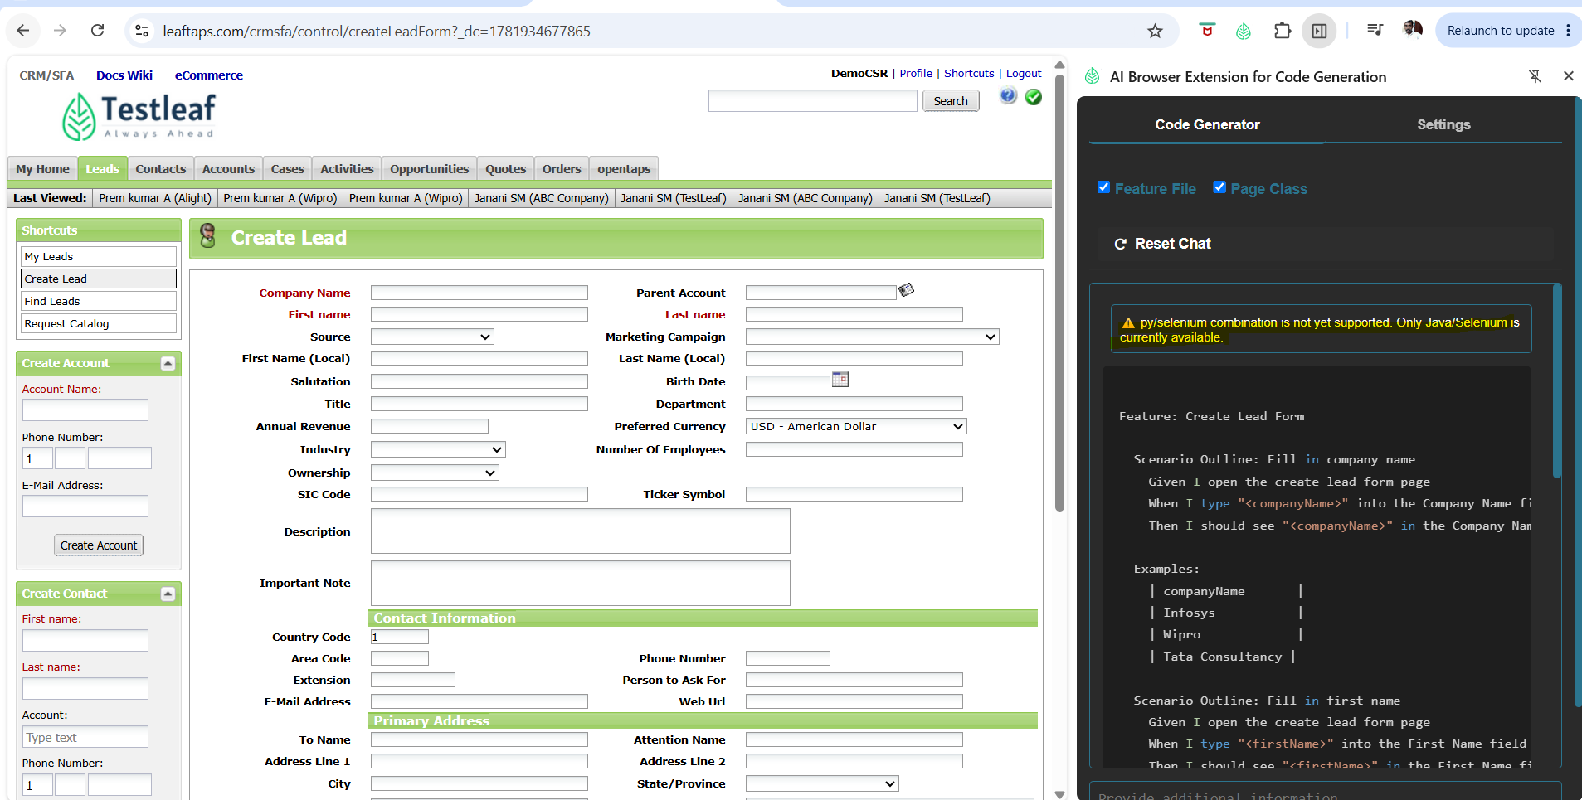

Ask Mode:
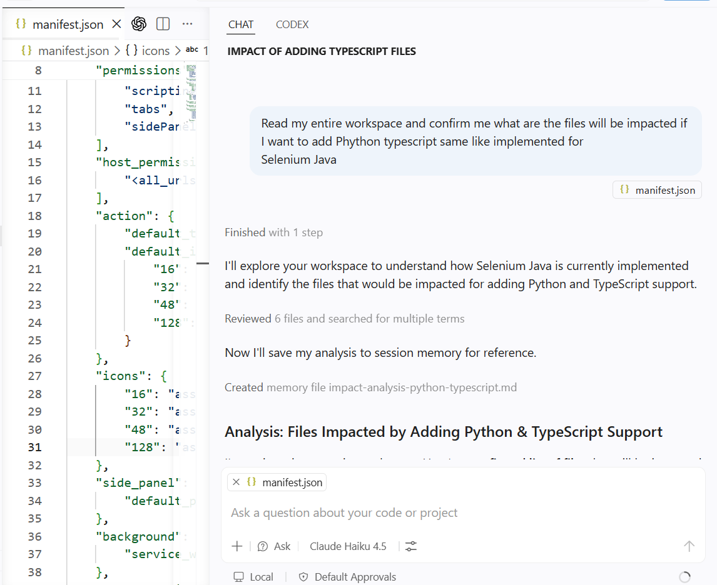

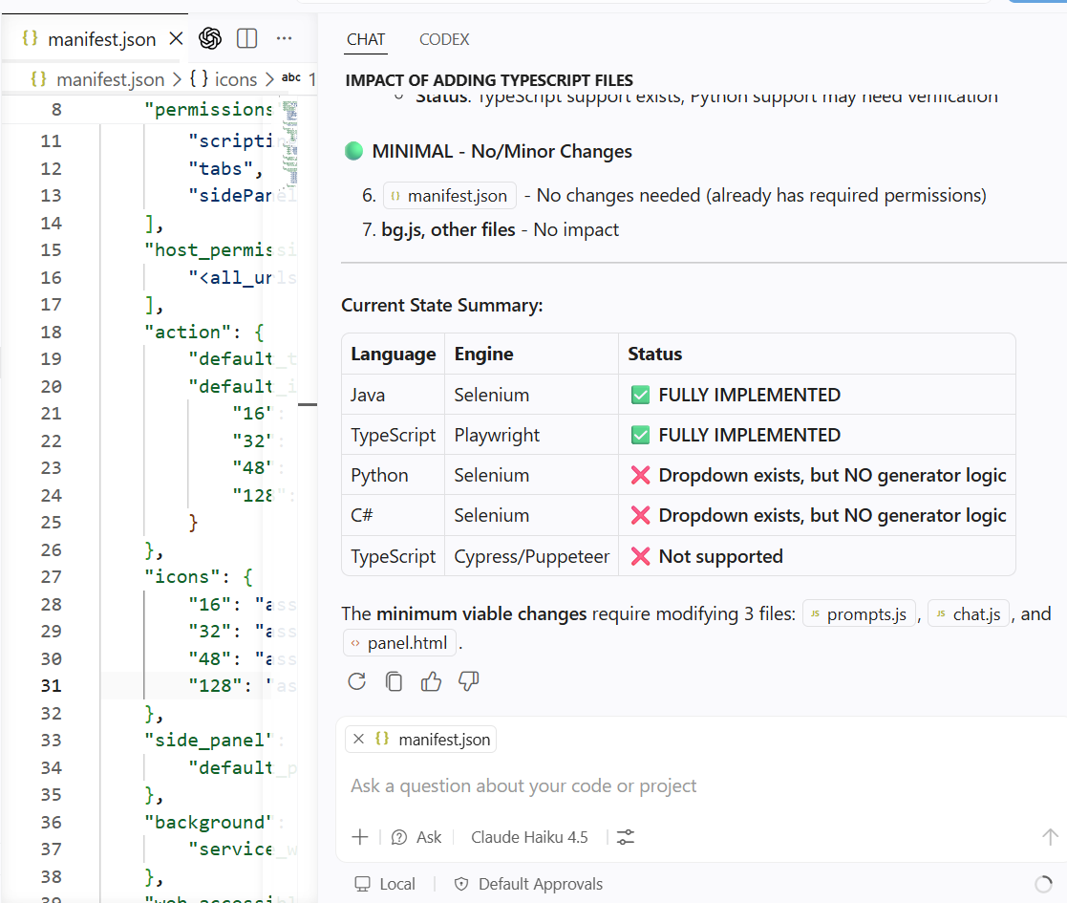
User: Read my entire workspace and confirm me what are the files will be impacted if I want to add Phython typescript same like implemented for
Selenium Java

GitHub Copilot: I'll explore your workspace to understand how Selenium Java is currently implemented and identify the files that would be impacted for adding Python and TypeScript support.

Read [](file:///d%3A/Test%20Leaf/Code/ai-extension/ai-extension)

Read [](file:///d%3A/Test%20Leaf/Code/ai-extension/ai-extension/panel.html#1-1), lines 1 to 100

Read [](file:///d%3A/Test%20Leaf/Code/ai-extension/ai-extension/src/config/appConfig.js)

Read [](file:///d%3A/Test%20Leaf/Code/ai-extension/ai-extension/src/scripts/prompts.js#1-1), lines 1 to 200

Searched for regex `java|python|typescript|csharp` (`**/*.js`), 20 results

Read [](file:///d%3A/Test%20Leaf/Code/ai-extension/ai-extension/src/scripts/chat.js#1-1), lines 1 to 300

Read [](file:///d%3A/Test%20Leaf/Code/ai-extension/ai-extension/src/scripts/popup.js#1-1), lines 1 to 200

Searched for text `languageBinding codeGeneratorType` (`**/*.js`), no results

Read [](file:///d%3A/Test%20Leaf/Code/ai-extension/ai-extension/src/scripts/prompts.js)

Read [](file:///d%3A/Test%20Leaf/Code/ai-extension/ai-extension/src/scripts/tabs.js)

Searched for text `initializeCodeGeneratorType languageBinding` (`**/src/scripts/chat.js`), no results

Read [](file:///d%3A/Test%20Leaf/Code/ai-extension/ai-extension/src/scripts/chat.js#400-400), lines 400 to 727

Read [](file:///d%3A/Test%20Leaf/Code/ai-extension/ai-extension/panel.html#1-1), lines 1 to 150

Now I'll save my analysis to session memory for reference.

Created memory file [](file:///c%3A/Users/param/AppData/Roaming/Code/User/workspaceStorage/e025c0500836925549493f053e9ab8ae/GitHub.copilot-chat/memory-tool/memories/Y2YwNjBjNTEtYjhjMy00NzU4LTgyMDQtMGJjYTMyNGYyMDBl/impact-analysis-python-typescript.md)

## Analysis: Files Impacted by Adding Python & TypeScript Support

I've reviewed your entire workspace. Here's a **confirmed list of files** that will be impacted when adding Python and TypeScript generators similar to your Selenium Java implementation:

### 🔴 **CRITICAL - Must Modify**

1. **prompts.js**
- **What's missing**: Python/TypeScript prompts are NOT defined
- **What to add**:
- `SELENIUM_PYTHON_PAGE_ONLY` - Python Page Object (similar to Java)
- `SELENIUM_PYTHON_WITH_STEPS` - Python + Cucumber step definitions
- `PYTEST_PYTHON_SPEC` - Pytest test specs
- Any TypeScript prompts beyond Playwright (Cypress, Puppeteer, etc.)
- **Current state**: Only has Java/Selenium and TypeScript/Playwright prompts

2. **chat.js**
- **What's incomplete**: Logic for handling Python/TypeScript selections
- **Methods that need updates**:
- `getPromptKeys()` - Only maps Java/Selenium and TypeScript/Playwright; doesn't handle Python or other TypeScript engines
- `isPythonSelenium()` - Method exists but **never used** in the prompt selection logic
- `isCSharpSelenium()` - Method exists but **never used**
- Need to add: Conditional logic for Python, C#, and extended TypeScript engine support
- **Issue**: All checkboxes are hardcoded as `javaGenerationMode` (HTML) - needs generic naming

3. **panel.html**
- **Issue**: Checkboxes are labeled `name="javaGenerationMode"` - too specific
- **Changes**: Rename to generic `name="generationMode"` for language agnostic functionality
- **Consider**: May need conditional checkbox display (different options for different language/engine combos)

### 🟡 **MODERATE - May Modify**

4. **sidepanel.css**
- Style adjustments if UI changes based on language selection
- Status: Minimal impact expected

5. **prism** (syntax highlighting)
- **Check**: Verify if `prism-python.js` exists
- **Status**: TypeScript support exists; Python support may need verification

### 🟢 **MINIMAL - No/Minor Changes**

6. **manifest.json** - No changes needed (already has required permissions)
7. **bg.js, other files** - No impact

---

### **Current State Summary:**

| Language | Engine | Status |
|----------|--------|--------|
| Java | Selenium | ✅ **FULLY IMPLEMENTED** |
| TypeScript | Playwright | ✅ **FULLY IMPLEMENTED** |
| Python | Selenium | ❌ **Dropdown exists, but NO generator logic** |
| C# | Selenium | ❌ **Dropdown exists, but NO generator logic** |
| TypeScript | Cypress/Puppeteer | ❌ **Not supported** |

The **minimum viable changes** require modifying 3 files: prompts.js, chat.js, and panel.html.

Agent Mode:
Prompt for agent mode :
C#/Selenium

Before Not Present
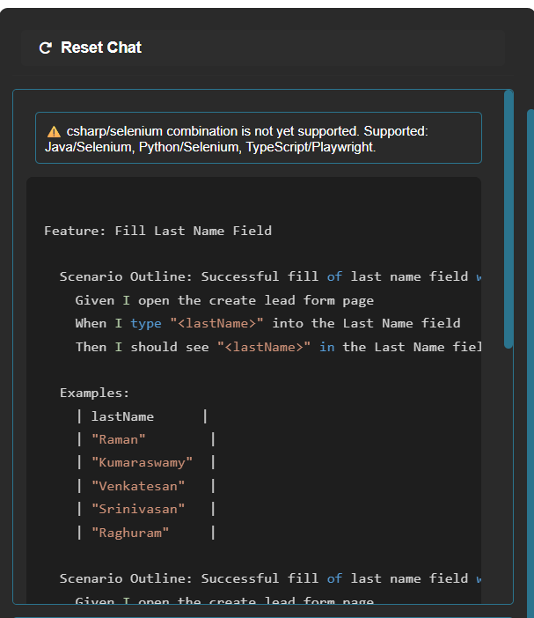
After changing files thru the GitHub Copilot able to generate
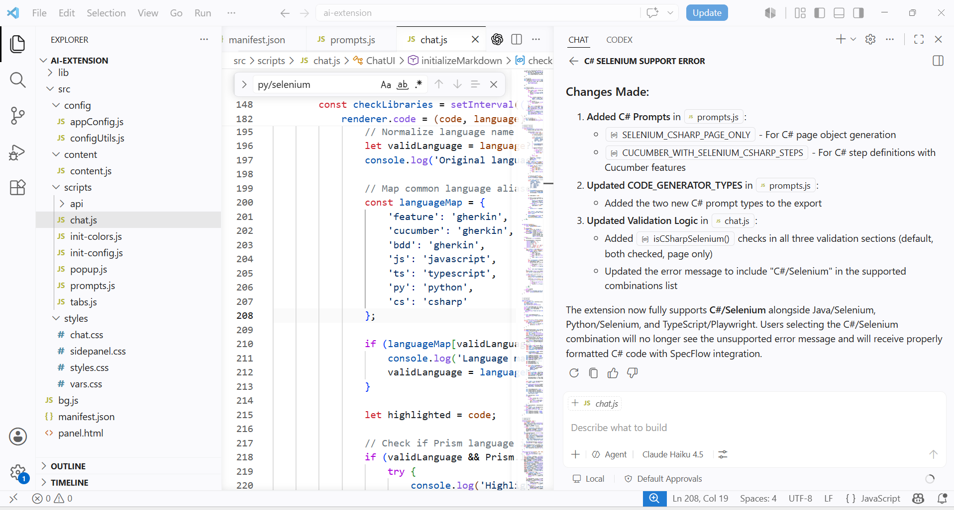

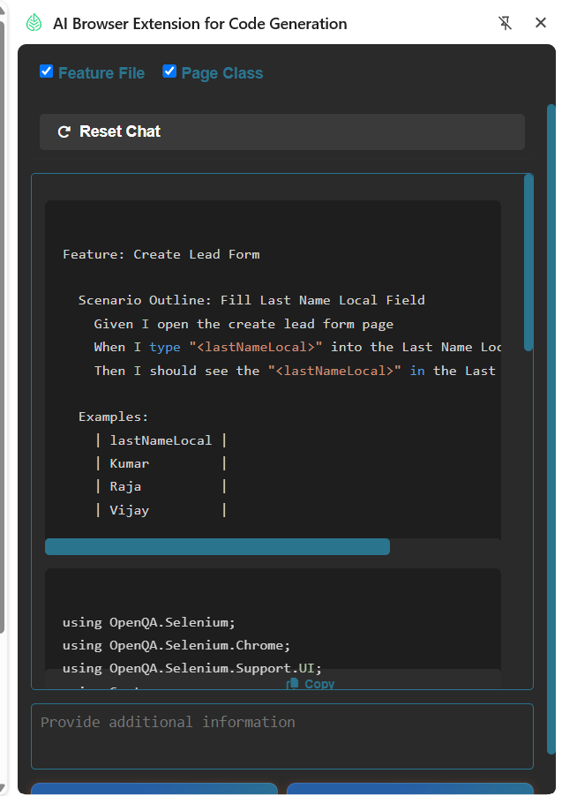

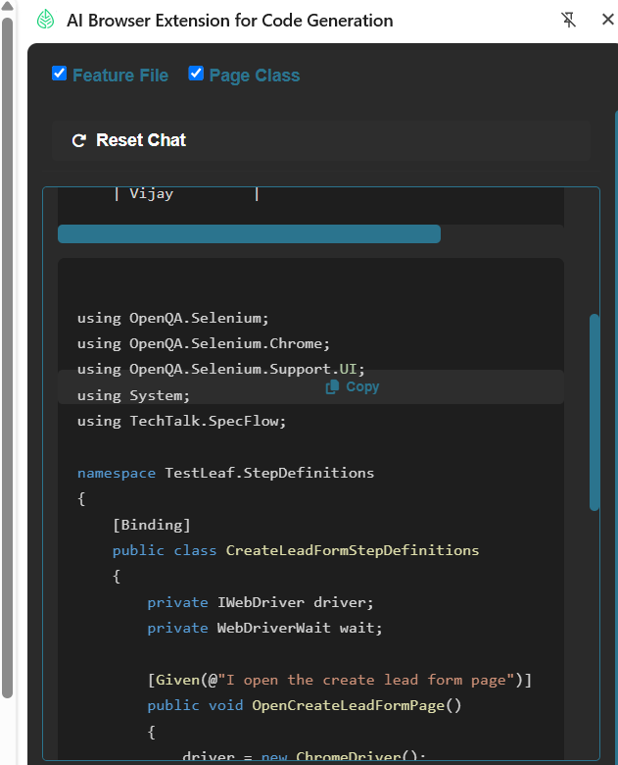
Feature:

Feature: Create Lead Form

Scenario Outline: Fill Last Name Local Field
Given I open the create lead form page
When I type "<lastNameLocal>" into the Last Name Local field
Then I should see the "<lastNameLocal>" in the Last Name Local field

Examples:
| lastNameLocal |
| Kumar |
| Raja |
| Vijay |

C# Code
using OpenQA.Selenium;
using OpenQA.Selenium.Chrome;
using OpenQA.Selenium.Support.UI;
using System;
using TechTalk.SpecFlow;

namespace TestLeaf.StepDefinitions
{
[Binding]
public class CreateLeadFormStepDefinitions
{
private IWebDriver driver;
private WebDriverWait wait;

[Given(@"I open the create lead form page")]
public void OpenCreateLeadFormPage()
{
driver = new ChromeDriver();
wait = new WebDriverWait(driver, TimeSpan.FromSeconds(10));
driver.Manage().Window.Maximize();
driver.Navigate().GoToUrl("https://leaftaps.com/crmsfa/control/createLeadForm?_dc=1781934677865");
}

[When(@"I type ""(.*)"" into the Last Name Local field")]
public void EnterLastNameLocal(string lastNameLocal)
{
IWebElement lastNameLocalField = wait.Until(ExpectedConditions.ElementToBeClickable(By.Id("createLeadForm_lastNameLocal")));
lastNameLocalField.SendKeys(lastNameLocal);
}

[Then(@"I should see the ""(.*)"" in the Last Name Local field")]
public void VerifyLastNameLocal(string lastNameLocal)
{
IWebElement lastNameLocalField = wait.Until(ExpectedConditions.ElementToBeClickable(By.Id("createLeadForm_lastNameLocal")));
Assert.AreEqual(lastNameLocalField.GetAttribute("value"), lastNameLocal);
}

[After]
public void TearDown()
{
driver?.Quit();
}
}
}

